 | Retrospective Award of Charterships | 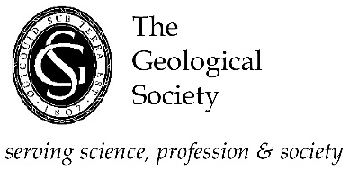

The Science Council has confirmed that those gaining Chartered Geologist status can be awarded Chartered Scientist status retrospectively up to a period of 2 years without the need for a further interview.
Procedure for Retrospective CSci Applications
- Application must be made within a 2-year period of the award of CGeol.
- Application to consist of the CGeol application together with a completed CSci application form.
- A CPD record for the intervening period post-CGeol shall be provided, together with evidence of M level work (if a Master’s degree MSc/MSci/MGeol is not held).
- A report which explains the fulfillment of the CSci criteria.
- The Supporting Documents, submitted for the CGeol application may be substituted but the Professional Report must be amended to demonstrate the scientific competency.
- The Application is to be submitted to the Chartership Officer who will decide on eligibility and will then request a review and recommendation from a CSci scrutineer.
- Accept recommendations will be passed to the Chairman of the Chartership Committee who will take it to the Chartership Committee for agreement at their next meeting and then on to Council for election.
- Defer recommendations will be reviewed by two CSci scrutineers and, if upheld, the applicant will be informed and advised on a future application.
Procedure for Retrospective CGeol Applications
- Application must be made within a 2-year period of the award of CSci.
- Application to consist of the original CSci application and a completed CGeol application form.
- A CPD record for the intervening period post-CSci shall be provided.
- A report which explains the fulfillment of the CGeol criteria, particularly i) and ii).
- The Supporting Documents submitted for the CSci application may be substituted, but the Professional Report must be amended to demonstrate fulfillment of all seven of the CGeol competency criteria i) to vii).
- The Application is to be submitted to the Chartership Officer who will decide on eligibility and will then request a review and recommendation from a CGeol scrutineer.
- Accept recommendations will be passed to the Chairman of the Chartership Committee who will take it to the Chartership Committee for agreement at their next meeting and then on to Council for election.
- Defer recommendations will be reviewed by two CGeol scrutineers and, if upheld, the applicant will be informed and advised on a future application.

